
SAOF Training of Level 1 Coaches

The Heritage day weekend of 24 to 27 September 2015 saw the delivery of the first-ever SAOF Orienteering Coach Assistant training course. This course was possible thanks to funding from SRSA and the generosity of the British Orienteering Federation (BOF) in sharing their knowledge and course work with us.
The Coach Assistant is the first designation within the SA Coaching Framework (SACF), often referred to as a Level 1 coach by many sporting federations. The SAOF Management Committed adopted a resolution in November 2011 to develop a formal coaching structure aligned with the SACF. The delivery of this program was the product of that commitment, which started in earnest in October 2012 when the BOF delivered their training program in South Africa, sharing their knowledge and expertise within this area.
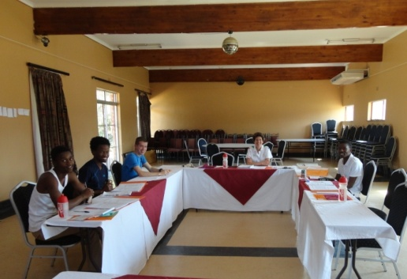
The Polokwane weekend consisted of three days of training, with a fourth day being used largely for the assessment process. The first day was mainly spent indoors, covering key theoretical aspects. Here the SACF lays the perfect structure for the required training. Whilst the candidate coach assistants (attendees) all had prior experience in delivering training through the SAOF’s O in the Box resource, the feedback was that until this course, they had not fully comprehended the critical part that a coach plays in shaping the life of the athlete. The day delivered key messages regarding the ethics of a coach and how orienteering skill acquisition links into the Long Term Athlete Development Model.
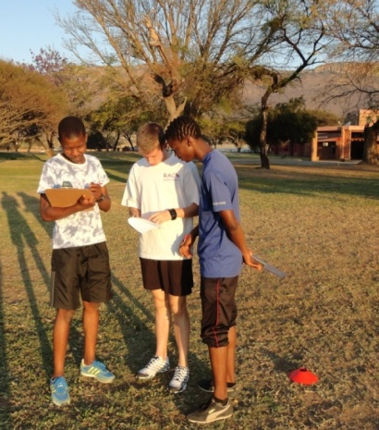
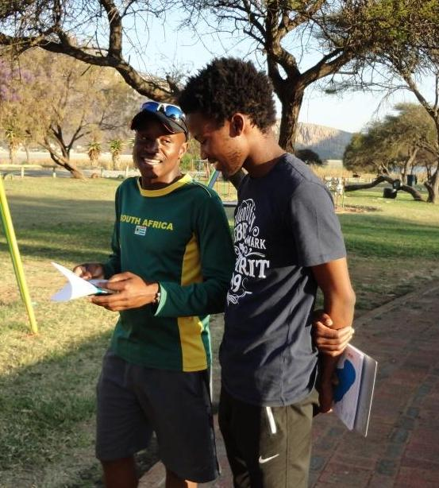
For day 2 and 3 the main emphasis was on the practical aspects of coach delivery. The attendees moved outdoors where they were required to plan, prepare, deliver and evaluate several coaching sessions. Through this process they were able to acquire the skills of how to coach, as well as looking at what to coach. The O in the Box resource was used as an important base for the first coaching session, as it provides coaches an easy to use pre-planned coaching sessions.

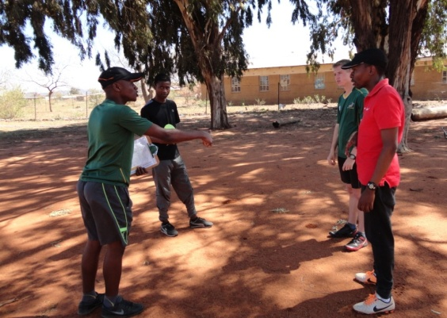
Thereafter the attendees (working in pairs) created their own sessions to teach a specific skill within the orienteering Step System. The Step System is a skills progression system which is perfectly aligned to the orienteering event structure. This allows all participants to be able to do events that are appropriate and challenging to their own skills set, whether that be at a beginner or advanced level. Attendees took it in turns to be coaches and athletes and grew in both capacities as the weekend progressed. By the end of the three days not only did they have the necessary theoretical knowledge behind sound sports coaching practices but had practical experience of guiding athletes on how to acquire the basic skills of orienteering.
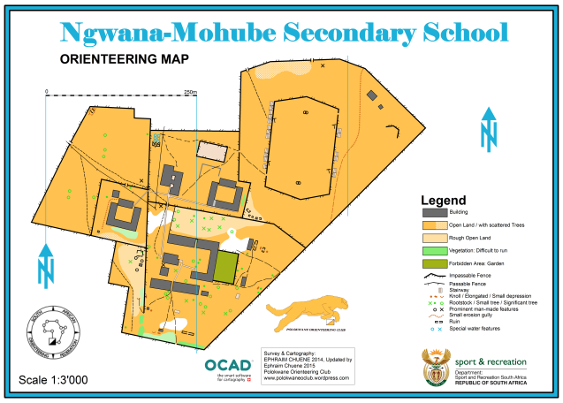
In order to provide suitable maps for the attendees to work with we were privileged to move around to various venues and used three superb maps made by Polokwane Orienteering Club founder. As one would expect, orienteering is an adventure, so we moved from park areas next to dams, further into the rural areas to a school in a village and finally to a technical college in Polokwane city itself.
The last day was an intensive one of assessment. Attendees had to deliver a final practical session and complete a knowledge questionnaire. Orienteering often creates a comradery amongst participants, and this weekend was no different. Attendees departed with mixed feelings, happy to be journeying home, enriched with the new coaching tools, eager to put those skills into practice, but sad that the weekend and our time together was over.
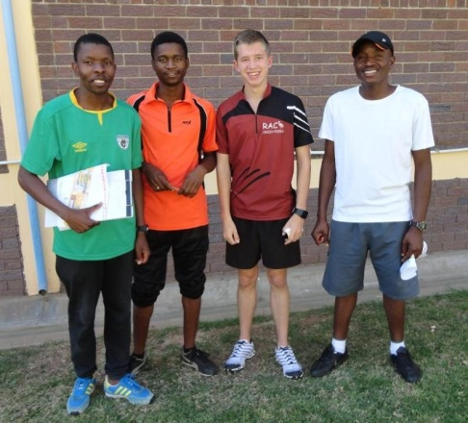
After the weekend the attendees had the following to say: “It gave me the mental, physical and interpersonal experience that is needed to help me fulfilled the role I am expected to undertake in Orienteering sport.”
“The weekend for me was an overall learning experience. Not only did I learn how to deal with the heat and be able to coach, but I learnt that my orienteering coaching experience was just about to begin. All my ideas that I was thinking up for trainings will now be able to become real and make a difference in someone else's orienteering career. “
“Wow what a weekend' that's my first words. At first it was me, but at the end it was a level 1 'O' coach, after being equipped with both knowledge and skills of coaching. From now on we will know what and how to deliver a coaching session within a particular time-frame. What I liked the most is the learning we acquired from each other while we were practicing the skills. I enjoyed the assessment day as we were all showing our abilities and confidences. Overall I may say I thank SAOF for the privilege and continued support as we will become one of their assets.”

