Fantastic start to our OSL 2017 season

A record number of 381 pupils from 18 different schools took part in our first League event
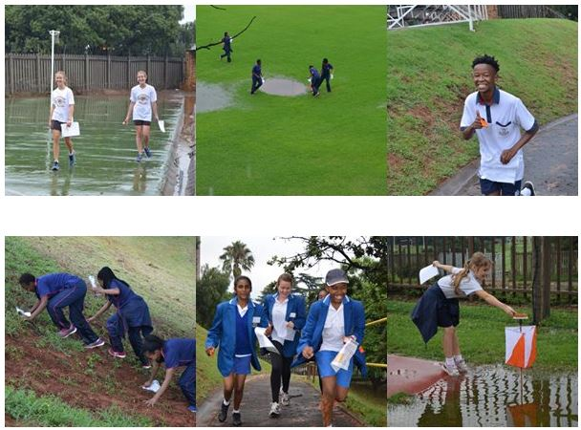
After a very wet start to the season at our Helpmekaar training event 381 athletes from 18 different schools enjoyed our first league event held at Parktown Boys.
A special welcome to our new Primary school pupils from Canterbury and Radford and High school pupils from Acres Academy and Parktown Boys.
Thank you to Helpmekaar Kollege for allowing us to host our training event at their school. Well done to Andries Swart, who with the assistance of Carl Holmes, updated the map and planned challenging courses. Many thanks to the large group of Club Orienteering volunteers who came and helped out in spite of the pouring rain. After heavy downpours the skies thankfully cleared enough for 133 competitors to still be able to go out and enjoy the event.
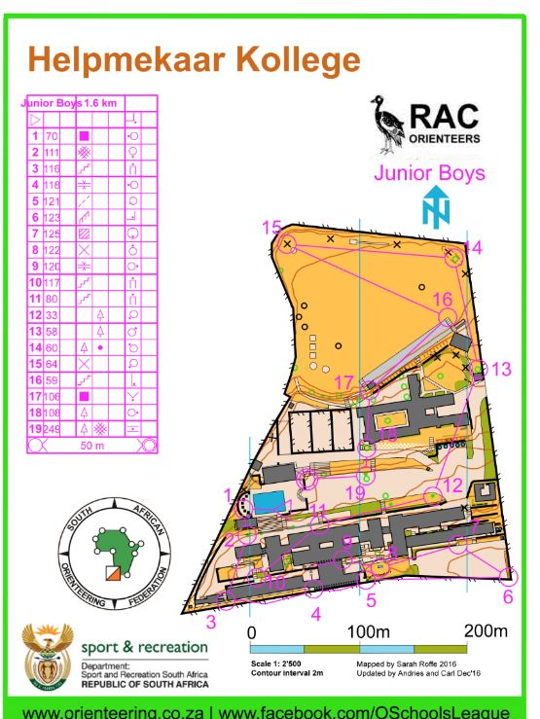
Thank you to Parktown Boys for allowing us to host our first league event at their school. A very busy afternoon with most schools arriving at the same time. Despite the large numbers of athletes and many other sporting activities happening at the same time everyone clearly enjoyed their afternoon. Well done to Timothy Chambers(UCT MSC) who updated the map and planned challenging but enjoyable courses with the help of Peter Carides (WITSOC).
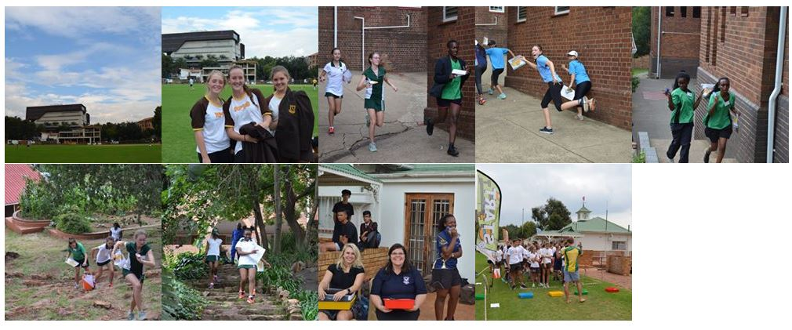
Well done to Helpmekaar who placed first on the Schools log.
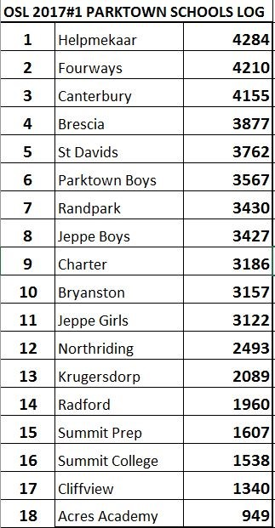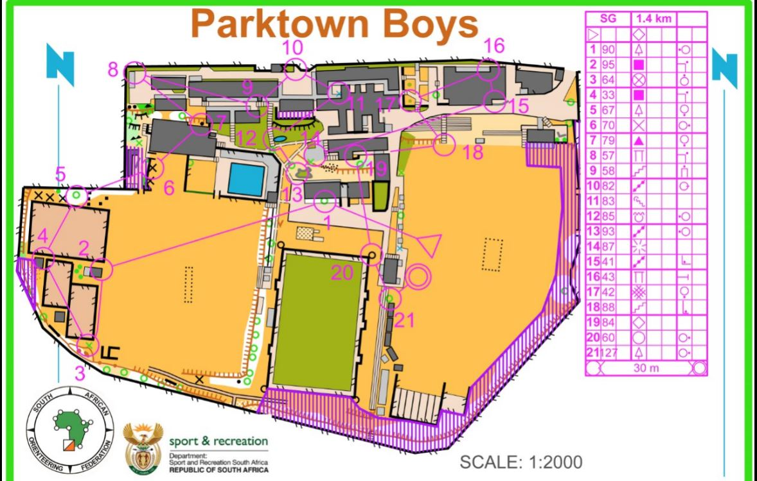
Congratulations to top athletes in each category:
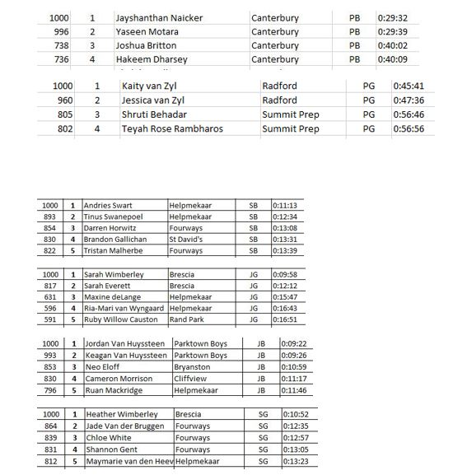
A number of competitors were disqualified for missing controls or punching incorrect controls. A reminder that there are four courses being run consecutively so not every control is on every course and will also be in a different order. On realising you have missed a control go back to the missed control and then return to the next one again. It is not a problem if extra controls are punched but all controls on the course need to appear in consecutive order to avoid disqualification e.g. punching 1,2,4,3,4,5… Please also remember to also punch the last control as well as the FINISH (F) control before having your result downloaded at the computer.
Please ensure that there is a new white back up card in your emit before going out on the course. These are important if the emit(electronic timing device) fails for some reason but please do not go back and look for the card if losing it. This week one of our controls unfortunately had a very sharp spike that removed a number of back up cards. Emits very seldom fail.
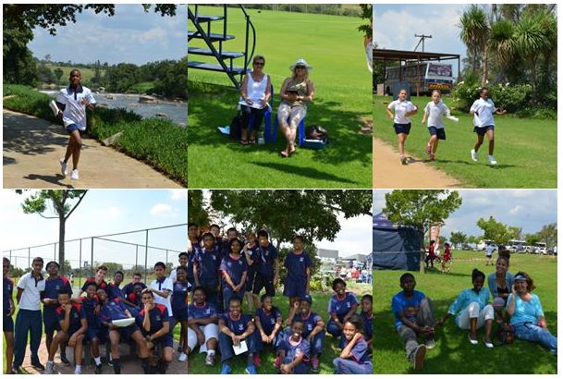
Many thanks to Heronbridge for allowing us to host this week’s event on their beautiful countryside school grounds that lend themselves perfectly to Orienteering. Competitors enjoyed beautiful views and had to ensure they made good route choices when navigating inbetween the school buildings. Well done to Brian and Christie Courtnage who updated the map and set well planned challenging but enjoyable courses for all categories.
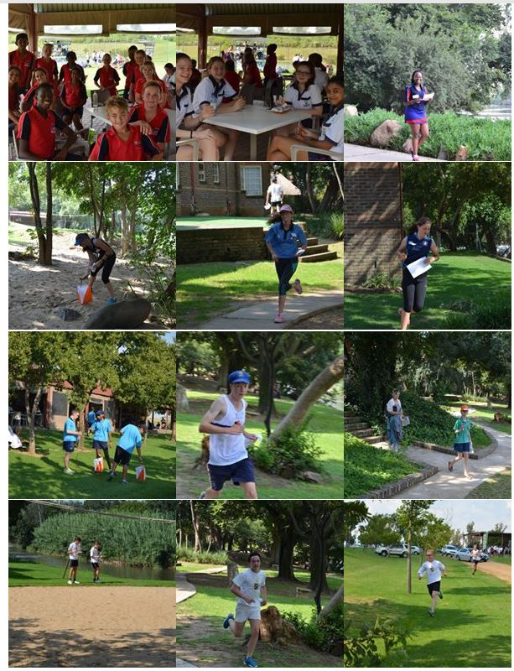
Well done to Brescia who were top of the Schools log for the day and to Fourways who now lead the Overall log.
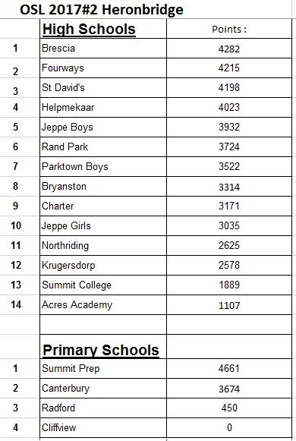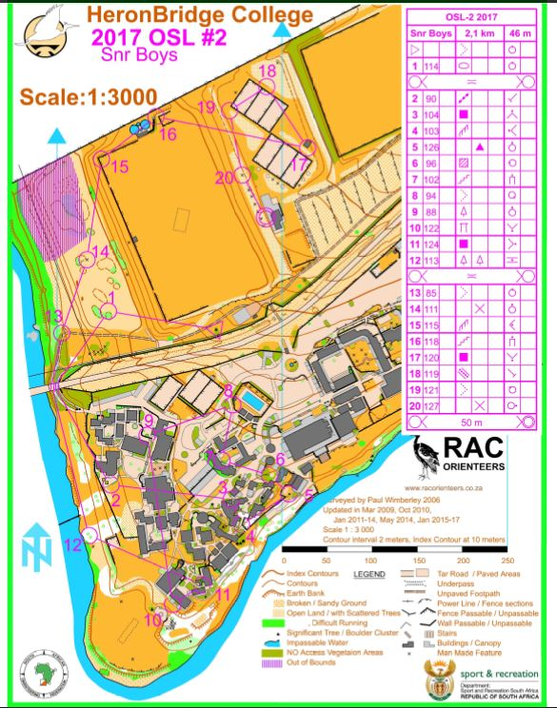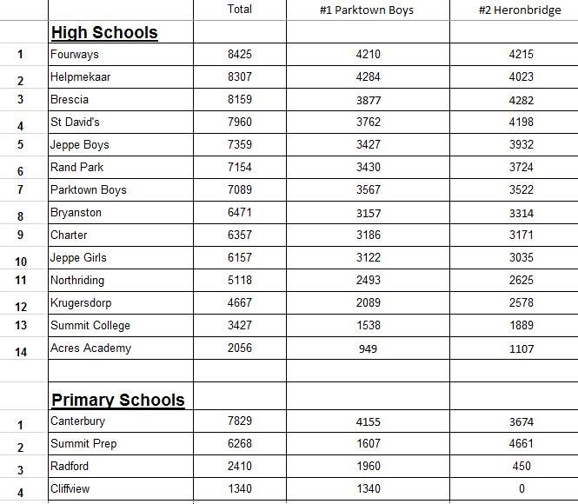
Congratulations to top athletes in each category :
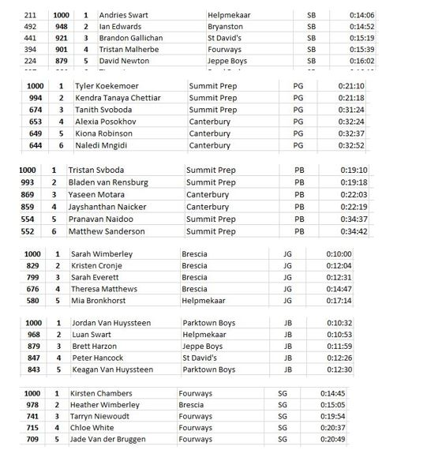
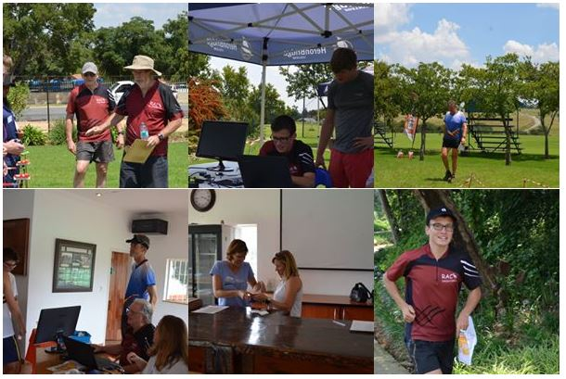
Thank you to my wonderful team of regular Orienteering Club volunteers without whom a successful OSL would not be possible. Special thanks to my dad Klaus, who does an amazing job at the computer and sorts out registers and results, Denise who assists at the Finish table, Audrey handing out of emits, Nicholas helping athletes understand why they were disqualified, Charles and Ian out on the course as well as Kieran, Rory, Christie, Timothy and Kirsten who help wherever needed. Thank you too to those teachers who are always so willing to assist. Your help is much appreciated.
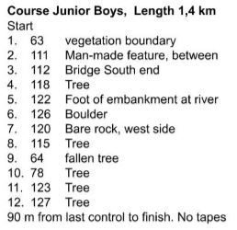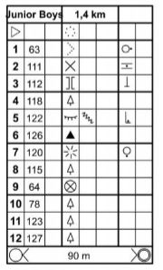
A reminder that control descriptions are posted on our Facebook page the week before an event. More experienced Orienteers prefer to have the control description easily visible on their arms rather than on the map so one can fold the map and keeps one’s thumb where one was last on the course. Simple arm holders can be made with wide sellotape.
If you are uncertain which direction is North and where the Start triangle is please ask the Starter to assist you. Only Primary school pupils are officially allowed to go out in pairs. If you do choose to work together with friends try not to get distracted and keep careful track of where you are on your map. Following others often leads to making of careless mistakes sometimes even causing disqualification as was the case for a number of competitors this week. Also remember if you qualify for the Final because of good results gained by following others you are certain to find courses rather challenging at the Final as there are preset Start times meaning you will have to work on your own.

